Machine Learning Algorithms for Solving Real-World Classification Problems

Lucas Oliveira   
Faculty of Engineering, Environment and Computing  
Coventry UniversityCoventry, England  
Lopesoll@uni.coventry.ac.uk Martin Tay  
Faculty of Engineering, Environment and Computing  
Coventry UniversityCoventry, England  
Taym5@uni.coventry.ac.uk

*Abstract*— The objective of this research paper is to examine the prediction of heart diseases with three classification algorithms. Cardiovascular disease is one of the prevalent causes of death in the world. The healthcare industry has a significant role to play in terms of providing timely intervention to save lives of vulnerable patients and the current number of annual cases around the world in terms of statistics is still disturbing and calls for a campaign to improve the well-being of humans in countries where the rates are terribly high.

The dataset used to perform this experiment is comprised of 253680 rows and 22 columns reflecting the input and target variables in the samples. The challenge brought by the imbalanced state of the dataset was resolved with the Scikit learn resampling techniques in python. Each sample contains 22 features, which were reduce to 17 features with recursive feature elimination method. The outcome of the experiments after training the three models with the heart disease dataset yielded the respective results %, %, and % models for the respective classification algorithms (Decision Tree, Support Vector Machine and Logistic Regression). Other activities like hyperparameter optimization and feature selection was explored to ensure the best effort on the predicted output variables. The overall performance of the classification algorithms would be measured against the relevant evaluation metrics parameters before and after training of the models.

Keywords— Cardiovascular Disease (CVD), Decision Tree, Support Vector Machines, Logistic Regression, Confusion Matrix, Recursive Feature Elimination)

# Introduction

Cardiovascular disease is one of the prevalent causes of death in the world and accounts for one of the most painful deaths that can be avoided under strict supervision. Cardiovascular diseases cause an average of 17.7 million deaths each year (44% of NCD fatalities) making it one of the most deserving topics for research on prevention. “Cardiovascular diseases (CVD) are a group of disorders of the heart and blood vessels which is the most significant cause of death globally[1]. Despite the critical fatality rate 90% CVD can be prevented by taking necessary precautions[2]. The impact of cardiovascular diseases can be very painful in the early years of any human being and have some ripple effects to the society due to the pain and economic effects on families and the economy of any country.

There are several risk factors that contribute to cardiovascular health conditions. It is no news that in most cases, the cause of the disease can be attributed to lifestyle and human preference of diets. Physical activities and healthy eating have been proven to help improve the health and well-being of humanity. The application of machine learning to predict cardiovascular diseases can help in the sensitization and improve the conditions of diagnosed patients. There are several case studies concerning cardiovascular diseases.

There are three types of prevention mechanisms to prevent and reduce the impacts of a disease. “Primary prevention refers to the steps taken by an individual to prevent the onset of the disease. This is achieved by maintaining a healthy lifestyle choice such as diet and exercise. “Secondary prevention focuses on reducing the impact of the disease by early diagnosis prior to any critical and permanent damage[1]. This facilitates avoiding life threatening situations and long term impairments from a disease. Tertiary prevention is used once long term effects set in, by helping the patients to manage pain, increase life expectancy, and increase the quality of life. The secondary prevention of CVD includes diagnosis and prevention. Most critical step of secondary prevention is early diagnosis which allows medical professionals to provide required care for patients and improve the quality of life. This requires identifying risk factors, criticality of risk factors, and how the variation of these factors relates to CVD . Upon early diagnosis, patients could be directed to required treatments affording a higher quality of life[1].

The inspiration for this research paper draws strength from the use of machine learning algorithms by medical professionals to make predictions of vulnerable patients and it is an improvement on the work initiated by [1]. Health improvements is tied to continuous research and implementation of state-of-the-art methodologies explored by experts to diagnose and prevent diseases like the one examined in our case study.

# PROBLEM AND DATA SET

As required, the purpose of this task is to make predictions with the independent variables and dependent variables. These independent variables contain certain information that may cause a cardiovascular condition in patients. The causes of cardiovascular disease borders around certain risk factors like blood pressure, obesity, age, sex, diet, exercise, smoking, health insurance, mental health, physical health, consumption of alcohol, rest, or sleep, and record of health check-up, etc. One major issue is the challenge with the imbalanced dataset and a resampling technique would be introduced to solve the problem. This in our case study is linked to what has been tagged as the independent features and they are outlined in the table below;

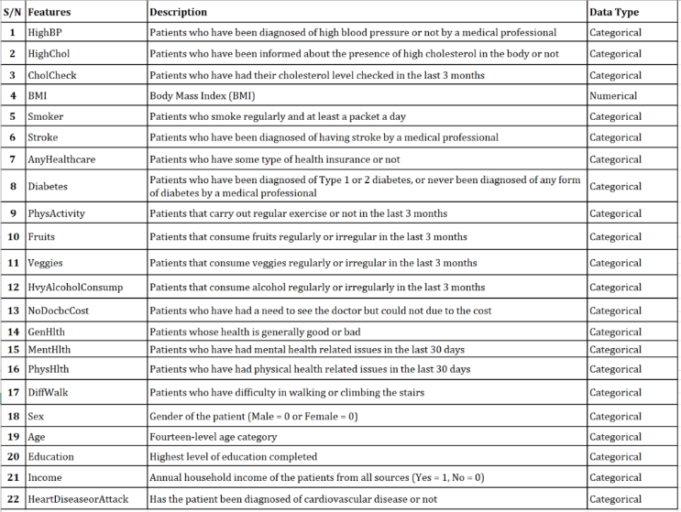

*Table 1 – Description of Independent and Dependent Features in the dataset*

The prediction of cardiovascular disease is a classification problem being that the outcome of the prediction is a categorical response variable based on certain predictor (multiple) variables, indicating whether a patient is diagnosed with a heart condition or not diagnosed. In machine learning, there are two major learning techniques, supervised learning, and unsupervised learning. Supervised learning algorithms are trained with labelled input and output data, while unsupervised learning algorithms are trained with unlabelled variables (*see figure 1 and 2*). The problem we have at hand is that of a supervised learning algorithm and both input and output data already labelled would be examined and evaluated when loaded unto the three classification algorithms selected for this experiment.

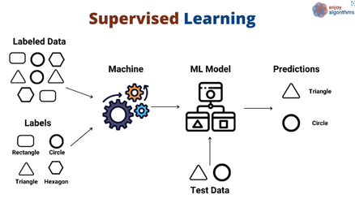

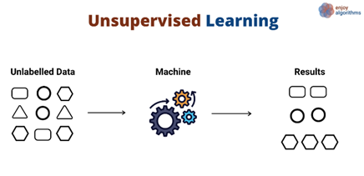

*Figure 1 and 2 – Graphic display of Supervised Learning and Unsupervised Learning*

 NOTE: From *Supervised and Unsupervised Learning (an Intuitive Approach)* by [3]

As depicted in the diagram above, figure 1 is an illustration of the data is processed before insights are gleaned in supervised learning algorithms. Insights are drawn by from the correlation between the interactive features against the response variable. This is usually an iterative process, which calls for the model to be trained until optimal performance is achieved and the model can make accurate predictions. The process of model optimization is called hyperparameter tuning and would be discussed in detail in the next section. Figure 1 and 2 depicts the learning process of unsupervised learning and how it generates insights or patterns for analysis. Learning for unsupervised is done with unlabelled data to reveal insights and patterns in the dataset. Key difference is in how the data is learned and processed before predictions are done.

# Methodology

## Data pre-processing

Data pre-processing is a crucial step before applying machine learning that involves preparing the data for the models. This step can drastically improve performance. A technique employed in this paper was handling null values, which was not required because the dataset contained no missing values. Other techniques that were used and are covered in detail in this section are Resampling, to handle the label imbalance, Standardization and Feature selection.

### Resampling

Imbalanced data makes the model predict a class more often that the other, leading to a high accuracy but poor results. This is a serious issue discussed in detail in section C. The original dataset contained imbalanced data, at a rate of 1:10 with 1 sample of class 1 for every 10 of class 0.

Several resampling models were compared, the comparison is available in the GitHub repository. The solution that yielded the best results is a combination of Random Over Sampler and Repeated Edited Nearest Neighbours.

#### RandomOverSampler

Random over-sampling works by randomly generating instances of the minority class or under-represented class.

#### RepeatedEditedNearestNeighbours

Edited Nearest Neighbours is an algorithm that applies the nearest-neighbour and removes samples which do not agree with the neighbourhood. Two selection criteria are available all, “all” and majority, “mode”. A sample is eliminated if the majority of the neighbours belong to the other class with “mode”. And using “all ”a sample is eliminated if any of the neighbours belong to the other class.

Repeated ENN repeats ENN multiple times resulting in the elimination of more samples. [5]

### Standardization

Standardization is a requirement for some linear learning models such as SVM and Logistic regression. These models assume that the data is centred around 0 and have variance in the same order. If one of the features has a greater scale leads the model to attribute a higher weight to that feature limiting the model from learning from other features.

#### Standard Scaller

Standard Scaler is extremely simple, it standardizes the features by removing the mean and scaling to unit variance. The standard score of a sample (x) is calculated:

z = (x - u) / s

Where u is the mean of training samples and s is the standard deviation of the training samples [6].

### Feature selection

Feature Selection is the process of reducing the number of features, in order to reduce the time taken to fit the algorithms and reducing the “noise” in the data, while minimizing information loss. In this paper, Recursive Feature Elimination (RFE) was implemented.

#### Recursive Feature Elimination

A variation of RFE was used, RFECV applies Recursive feature elimination with cross validator to find the optimal number of features.

RFE utilizes an external estimator that assigns weights to features, such as the coefficients of a linear model, the model then recursively removes a given number of features on each iteration until the number of features to select is reached, this number is also passed to the algorithm in the parameters. [7]

## Machine learning models

### Decision Tree Classifier

Decision Tree Classification algorithm is one of the simplest techniques to implement in solving classification or regression problems. The supervised learning model learns from the class labels/interactive features by making system-based rules that guides its decision to make predictions. In the words of [4], Decision Tree learning method is a method for approximating discrete-valued target functions, in which the learned function is represented by a decision tree”.

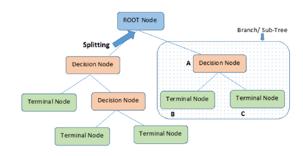

*Figure 5 – A diagram of a decision learning process in Decision Tree. From Decision Tree Algorithm – A Complete Guide by [5]*

The root node is where the learning process begins with several splits into finite terminal nodes before making a prediction. To make decisions before splitting, decision tree uses the amount of information gained about to improve the nodes. The information gained is measured by the entropy and mathematically expressed in the formula below, “where X is the random variable or process, Xi is the possible outcomes, and p(Xi) is the probability of the possible outcomes”[6].

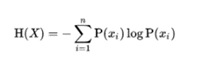

Figure 3

*NOTE: From A Complete Guide to Decision Tree Split using Information Gain, by [6].*

By definition, [6], the entropy of any random variable or random process is the average level of uncertainty involved in the possible outcome of the variable or process.

### Logistic Regression

The third classification algorithm used in this experiment is Logistic Regression. In machine learning, logistic regression uses the concept of probability to make predictions in classification problems. “The hypothesis in logistic regression tends to limit the cost function between 0 and 1” [7]. This is mathematically expressed as;

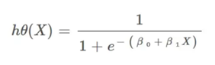

Figure 4

NOTE: The hypothesis of logistic regression. From: Introduction to Logistic Regression, by [7].

### Suport Vector Machine

Support vector machine is a classification algorithm which performs its prediction by splitting the classes into two groups with a line mathematically positioned by two support vectors surrounding a hyperplane, typically, in a multidimensional space.

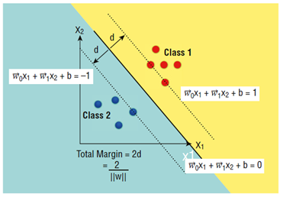

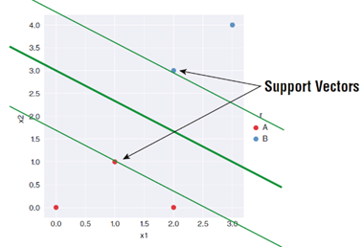

*Figure 6 and 7 – Graphical display of how prediction is performed in support vector machine classification, From Python Machine Learning, by [8]*

## Evaluation metrics

In a problem with imbalanced labels as this one accuracy can not be used to evaluate a model. When a model is fed extremely imbalanced data is going to predict only the majority class, resulting in near 100% accuracy even tough the model is terrible at prediction one of the classes. This is why other evaluation metrics must be used.

### Confusion Matrix

Confusion matrix is a performance evaluation metric for classification problems. It show a table representing the combinations of actual and predicted values [9].

### Precision

Precision represents the ratio of correctly predicted true positives to the total number of values predicted positive.

Precision = TP/(TP + FP)

### Recall

Recall is the ratio of correctly predicted true positives to the total number of positive values.

Recall = TP/(TP + FN)

### F1-Score

F1-Score it the harmonic mean of precision and recall combining them in one single metric [10].

F1 = 2 x [(Precision x Recall) / (Precision + Recall)]

Is important to mention that not one single metric fits all needs, more than one must be analysed to evaluate the model.

## Hyperparameter tunnig

Hyperparameter tunning is the process of fitting the model with a given set of parameters and return the optimal set of parameters for the given model. In this paper we used GridSearchCV to perform this task.

### Grid search

GridSearchCV fits the given set of parameters into the given learning model and scores every combination of parameters. Then using the “best_params_” attribute the best set of parameters is returned [8].

# Experimental Setup

The dataset originally has 253680 rows and 22 columns. After the label imbalance issue was found the first concern was comparing resampling techniques. All the code comparing the resampling techniques is available in the git hub repository.

## Resampling techniques

A major issue when using resampling techniques is data leakage. Data leakage occurs when the data is resampled before being split into training and testing sets. Two issues emerge from this, the test data should be naturally imbalanced to properly test the algorithm, if the entire dataset is resampled the test set is not going to reveal potential bias of the model. The second issue is that some resampling algorithms like random over sampler or ENN utilize other samples to generate or select other samples, therefor the same information is going to be in the train and test sets (data leakage) [11].

### Repeated ENN

The parameter number of neighbours to consider (n_neighbours) was set to 7 because the higher the number of neighbours more samples are being removed, and 7 resulted in a satisfactory ratio between both labels.

## Feature selection

RFECV was used to find the optimal number of features. The data was then transformed using the transform method, the optimal number of features for this dataset is 17. Bellow is a plot showing the number of features against the mean test accuracy.

Figure 8: Mean test accuracy per Number of features plot

## Machine learning models and hyperparameter tunning

### Decision Tree Classifier

The parameter being modified for this model are max_depth, criterion, and class_weight

### Logistic Regression

### Suport Vector Machine

TABLE II. Table Type Styles

| Table Head | Table Column Head | | |
| --- | --- | --- | --- |
| Table column subhead | Subhead | Subhead |
| copy | More table copya |  |  |

1. Sample of a Table footnote. (*Table footnote*)
2. Example of a figure caption. (*figure caption*)

Figure Labels: Use 8 point Times New Roman for Figure labels. Use words rather than symbols or abbreviations when writing Figure axis labels to avoid confusing the reader. As an example, write the quantity “Magnetization”, or “Magnetization, M”, not just “M”. If including units in the label, present them within parentheses. Do not label axes only with units. In the example, write “Magnetization (A/m)” or “Magnetization {A[m(1)]}”, not just “A/m”. Do not label axes with a ratio of quantities and units. For example, write “Temperature (K)”, not “Temperature/K”.

##### References

1. Ganegoda, G. (2018). Secondary Prevention of Cardiovascular Diseases and Application of Technology for Early Diagnosis. <https://www.researchgate.net/publication/325033300_Secondary_Prevention_of_Cardiovascular_Diseases_and_Application_of_Technology_for_Early_Diagnosis>. Hindawi BioMed Research International, Volume 2018, https://doi.org/10.1155/2018/5767864
2. McGill, H. (2008), “Preventing heart disease in the 21st century implications of the pathobiological determinants of atherosclerosis in youth (PDAY) study,” Circulation, vol. 117, no. 9, (pg. 1216–1227)
3. Kozan, M. (2021). <https://medium.com/@metehankozan/supervised-and-unsupervised-learning-an-intuitive-approach-cd8f8f64b644>)
4. Mitchell, T. (1997). Machine Learning. McGraw Hill Companies (pg. 52)
5. Saini, A. (2021). Decision Tree Algorithm – A Complete Guide. https://www.analyticsvidhya.com/blog/2021/08/decision-tree-algorithm/
6. Verma, Y. (2021). A Complete Guide to Decision Tree Split using Information Gain. (<https://analyticsindiamag.com/a-complete-guide-to-decision-tree-split-using-information-gain/>)
7. J. Clerk Maxwell, A Treatise on Electricity and Magnetism, 3rd ed., vol. 2. Oxford: Clarendon, 1892, pp.68–73.
8. Dey, A. (2016). Analysis of Supervised Machine Learning Algorithms for Heart Disease Prediction with Reduced Number of Attributes using Principal Component Analysis. https://www.researchgate.net/publication/301335834_Analysis_of_Supervised_Machine_Learning_Algorithms_for_Heart_Disease_Prediction_with_Reduced_Number_of_Attributes_using_Principal_Component_Analysis/link/583d2af708ae502a85e53634/download
9. Mwanthi, D. (2022). Getting started with Recursive Feature Elimination algorithm in Machine Learning https://www.section.io/engineering-education/recursive-feature-elimination/#:~:text=the%20RFE%20algorithm.-,Implementing%20RFE%20algorithm,data%20into%20a%20decision%20tree.&text=The%20output%20above%20shows%20that%20the%20optimal%20number%20of%20features%20is%20t
10. *Under-sampling*. Imbalanced-learn.org. (2022). Retrieved December 14, 2022, from https://imbalanced-learn.org/stable/under_sampling.html#edited-nearest-neighbors
11. *Sklearn.preprocessing.StandardScaler*. Sklearn. (2022). Retrieved December 12, 2022, from https://scikit-learn.org/stable/modules/generated/sklearn.preprocessing.StandardScaler.html#sklearn.preprocessing.StandardScaler
12. *1.13. feature selection*. scikit-learn.org. (2022). Retrieved December 14, 2022, from https://scikit-learn.org/stable/modules/feature_selection.html#rfe
13. *Sklearn.GRIDSEARCHCV*. scikit-learn.org. (2022). Retrieved December 14, 2022, from https://scikit-learn.org/stable/modules/generated/sklearn.model_selection.GridSearchCV.html#sklearn.model_selection.GridSearchCV
14. Narkhede, S. (2021, June 15). *Understanding confusion matrix*. Medium. Retrieved December 14, 2022, from https://towardsdatascience.com/understanding-confusion-matrix-a9ad42dcfd62
15. Johnson, J. (2020, July 22). *Precision, recall & confusion matrices in Machine Learning*. BMC Blogs. Retrieved December 14, 2022, from https://www.bmc.com/blogs/confusion-precision-recall/
16. *8. common pitfalls and recommended practices#*. imbalanced-learn.org. (2022). Retrieved December 15, 2022, from https://imbalanced-learn.org/stable/common_pitfalls.html

**IEEE conference templates contain guidance text for composing and formatting conference papers. Please ensure that all template text is removed from your conference paper prior to submission to the conference. Failure to remove template text from your paper may result in your paper not being published.**